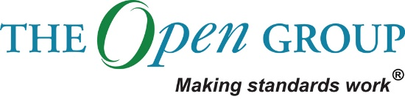

Statement of Architecture Work

Common Data Platform  
Vår Energi

Table of Contents

1 Purpose of this Document 3

2 Statement of Architecture Work 4

3 Objectives and Scope 7

4 Roles and Responsibilities 8

5 Architecture Approach 10

6 Work Plan 13

7 Project backlog 13

8 Risks and Mitigations 21

9 Acceptance Criteria and Procedures 22

10 Signature Approvals 23

Document Information

|  |  |  |  |
| --- | --- | --- | --- |
| **Project Name:** | Data Platform | | |
| **Prepared By:** |  | **Document Version No:** |  |
| **Title:** | Statement of Architecture Work | **Document Version Date:** | 29.05.20 |
| **Reviewed By:** |  | **Review Date:** |  |

Distribution List

| **From** | **Date** | **Phone/Fax/Email** |
| --- | --- | --- |
|  |  |  |
|  |  |  |

| **To** | **Action\*** | **Due Date** | **Phone/Fax/Email** |
| --- | --- | --- | --- |
|  |  |  |  |
|  |  |  |  |
|  |  |  |  |
|  |  |  |  |

* Action Types: Approve, Review, Inform, File, Action Required, Attend Meeting, Other (please specify)

Document Version History

| **Version Number** | **Version Date** | **Revised By** | **Description** | **Filename** |
| --- | --- | --- | --- | --- |
|  |  |  |  |  |
|  |  |  |  |  |

# Purpose of this Document

This document is a Statement of Architecture Work for the Common Data Platform in Vår Energi.

The Statement of Architecture Work defines the scope and approach that will be used to complete an architecture project. The Statement of Architecture Work is typically the document against which successful execution of the architecture project will be measured and may form the basis for a contractual agreement between the supplier and consumer of architecture services. In general, all the information in this document should be at a high level.

It may be that the Statement of Architecture Work is documented using a wiki or as an intranet rather than a text-based document. Even better would be to use a licensed TOGAF tool that captures this output.

This template shows “typical” contents of a Statement of Architecture Work and can be adapted to align with any TOGAF adaptation being implemented.

# Statement of Architecture Work

## Project Request and Background

Vår Energi is one of the largest E&P companies on the NCS and have an ambition to grow. In 2019 Vår Energi established a Digital Transformation Program, as it was expected from the owners, the competitors worked on digitalization and employees were eager for new ways of working. When defining their digital vision and roadmap, various digital initiatives were defined to make sure Vår Energi reach their digital vision of “turning bytes to barrels”.

Today, Vår Energi has a legacy IT landscape that does not support the digital vision and business plans, and **the current IT landscape lacks a common way of accessing, sharing and collating information across units and systems**. This makes it difficult to do analyses, make reports, build dashboards that involves information from across several IT systems and business units, with the current IT landscape. In addition, it is nearly impossible to collate information from the multitude of systems as there is no common way of modeling the information found in these systems. There is required a large amount of manual work when collating and consolidating information, making the processes inefficient and time consuming.

A common data platform will be able to ingest the information found in the different IT systems across the different business units and prepare it for use. It will thus be an **essential enabler for many of Vår Energi’s planned digitalization initiatives** and should extend the capabilities of the current underlying technology platform, information availability and governance to support Vår Energi’s digitalization roadmap and strategy. Prioritized initiatives that have the Data Platform as a prerequisite for success is Energy Management System, Production Dashboarding, Mobility in Field Operations and Supply Chain Control Tower. Additionally, there are several initiatives in the pipeline, such as Monitoring of Heat Exchangers, Mechanical Integrity Management, emulsion management, integrity chemicals

In addition to enabling the digital initiatives **the data platform also enables ICT to become more efficient**. ICT currently manages an IT landscape without any integration platform, which makes it difficult to ensure data flows between different systems and applications. The data platform will provide a mechanism that can make ICT more efficient and effective in their activities, by easier configuration and management of data flows.

## Project Description and Scope

**Architecture / Design phase Scope**

The scope for the Data Platform Design Phase is to Design the Data Platform Architecture and evaluate products to acquire, with the objective to lay the foundation for implementation of the Data Platform.

**Implementation project scope**

The scope for the Data Platform Implementation Phase is to implement a MVP common Data Platform in Vår Energi using Azure Cloud. Before implementation, the architecture will be further detailed and the vendors validated.

The scope of the implementation is as follows:

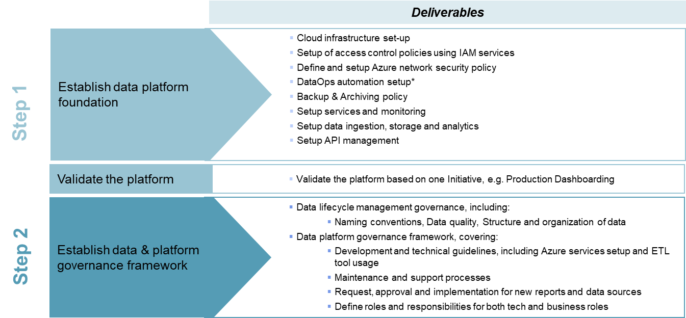

## Strategic Alignment

See Chapter 2.1

# Objectives and Scope

## Objectives

The business objectives of this architecture work are as follows:

* Flexibility to start small and scale as needed and utilize services and software that can scale without license-changes according to usage
* Integration towards 3rd party vendors to get best solution to support both current and future business needs while retaining independency and minimize vendor lock-in
* Enable the use of many different end-user tools and applications to best fit end-users’ purpose and thus increase efficiency
* One single-source-of-truth
* Make it easier to find data through data and system documentation
* Increased data sharing, reuse and delivery across the business functions which will enable more efficient business operations by breaking organizational silos

## Scope

See Chapter 2.3

## Stakeholders, Concerns, and Views

|  |  |  |
| --- | --- | --- |
| **Role** | **Concerns about the business** | **Concern about the Data Platform** |
| Digitalization Manager | Responsible for the Digital Portfolio and concerned about implementing digital initiatives in the organization | Data Platform important enabler for several digital initiatives and the digital portfolio, and the digitalization manager is thus concerned for the progress of the project as it impacts the progress of the digital program |
| ICT Manager | Concerned about making sure that the ICT department delivers on the business unit’s needs. | Project owner for the Data platform implementation project. Concerned about implementation progression, budget and the quality of the delivery. |
| Architecture Board |  | How the Data Platform Architecture affects and aligns with the existing architecture and the organization’s needs. |
| Infrastructure Team | Ensuring that the infrastructure support the business needs/requirements | Concerned about security and efficiency of the infrastructure in the data platform and how it integrates with the rest of the IT architecture in VE. Additionally, they are concerned about the management of the infrastructure. |
| IM Team | Enable the business to use data in an efficient manner | The Data Platform is intended to store and manage a lot of VEs data. IM team is concerned about data lifecycle management in the data platform. |
| Digitalization Team | Enable digital transformation in the organization | Data Platform important enabler for several digital initiatives and the digital portfolio, and the digitalization manager is thus concerned for the progress of the project as it impacts the progress of the digital program |
| AM Team | Ensuring that the applications support the business needs/requirements | The AM team is responsible for managing the applications in Vår Energi. They are concerned about making sure that the applications in the data platform are managed in a secure and efficient way. |

## Managerial Approach

What is expected of this section?

## Change of Scope Procedures

What is expected of this section?

# Roles and Responsibilities

## Governance Structure and Project Processes

Outline the team structure – e.g., simple organization chart showing roles and reporting lines

Outline key project processes – e.g., regular meetings, steering boards, document repository, configuration management, quality assurance, escalation procedure, change procedure.

* Legg inn Design Fase

**The Data Platform Implementation Team**

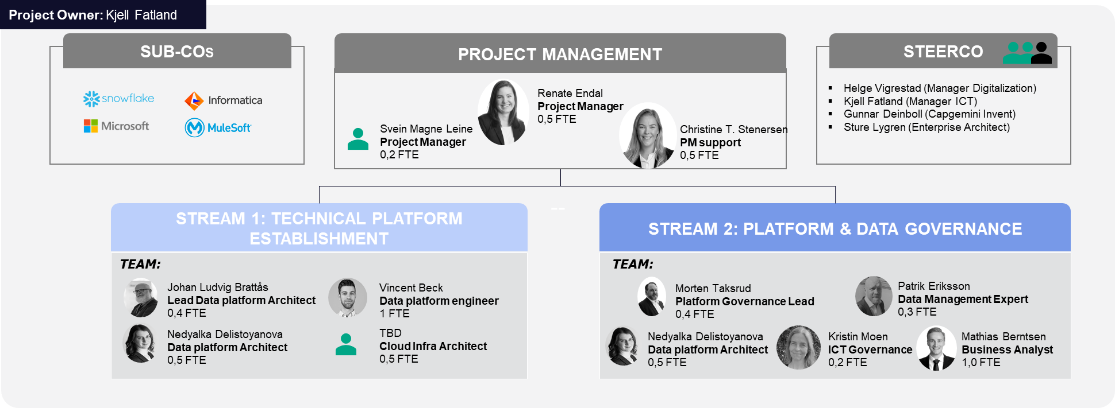

**Communication Overview**

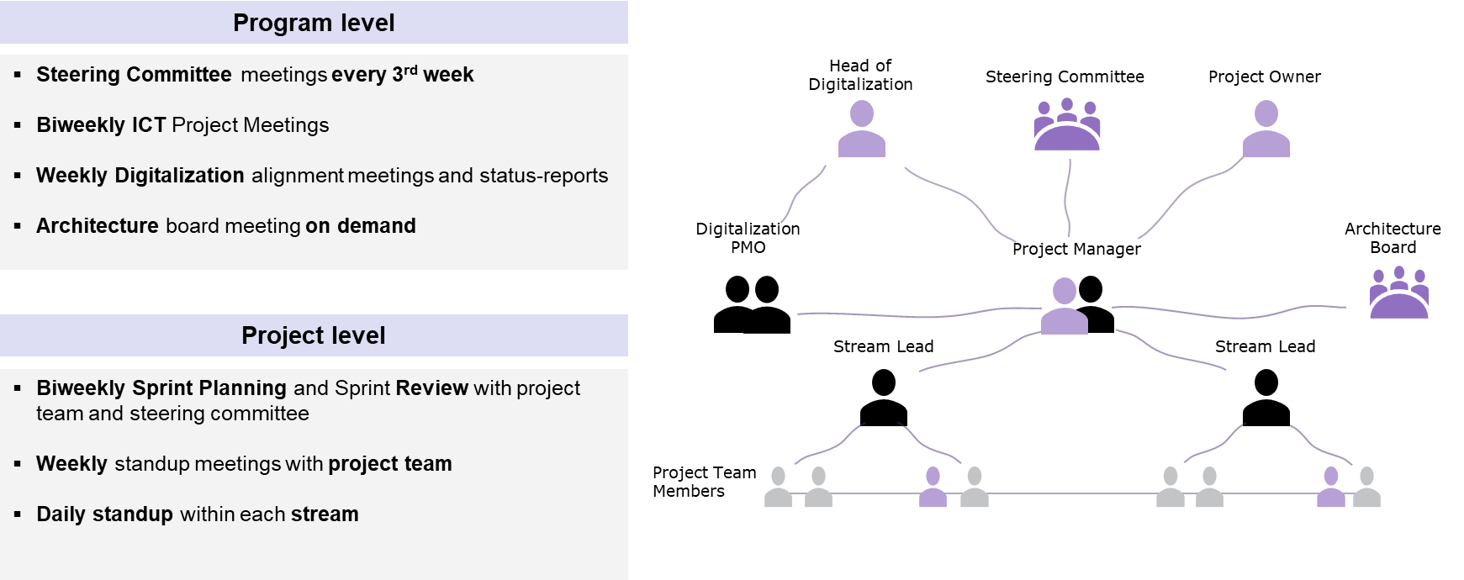

## Roles and Responsibilities (RACI)

A RACI can be provided upon request at a later point

# Architecture Approach

Identifisere nå og fremtid + prosessen

Beskrive hvordan dette har foregått så langt

## Architecture Process

For the Data Platform project, the Digitalization delivery model is followed: Design Phase, Implementation with MVP before Scaling. Agile.

**Design Phase Approach**

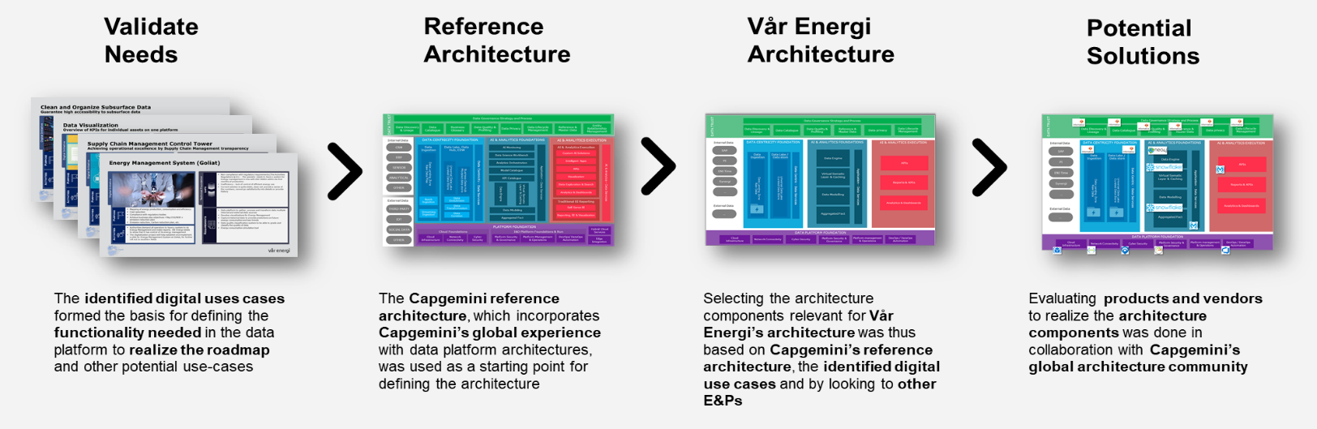

The TOGAF Architecture Development Method (ADM) defines a best-practice methodology for architecture development. However, not all phases are necessarily equally relevant to every project. The table below describes the usage of the ADM for this particular project.



|  |  |  |
| --- | --- | --- |
| **Phase** | **In/Out** | **Notes** |
| Preliminary |  |  |
| A – Architecture Vision |  |  |
| B – Business Architecture |  | <<Baseline and/or Target?>> |
| C – Information Systems Architecture |  | <<Baseline and/or Target?>> |
| D – Technology Architecture |  | <<Baseline and/or Target?>> |
| E – Opportunities and Solutions |  |  |
| F – Migration Planning |  |  |
| G – Implementation Governance |  |  |
| H – Architecture Change Management |  |  |
| Requirements Management |  |  |

<<Provide any further notes on phasing, iterations, etc.>>

## Architecture Content

The TOGAF Architecture Content Framework (ACF) provides a best-practice categorization of architecture content. However, not all items are necessarily equally relevant to every project. The table below describes the content areas relevant to this particular project.



|  |  |  |
| --- | --- | --- |
| **Content Area** | **In/Out** | **Notes** |
| Architecture Principles, Vision, and Requirements |  | <<Note which sub-categories will be covered>> |
| Business Architecture |  | <<Note which sub-categories will be covered>> |
| Information Systems Architecture – Data |  | <<Note which sub-categories will be covered>> |
| Information Systems Architecture – Applications |  | <<Note which sub-categories will be covered>> |
| Technology Architecture |  | <<Note which sub-categories will be covered>> |
| Architecture Realisation |  | <<Note which sub-categories will be covered>> |

<<Provide any additional insight into stakeholder concerns and particular views that will be created as a result.>>

## Relevant Methodologies and Industry Standards

**~~Implementation Phase / MVP approach~~**

~~The Implementation phase takes point of departure in the output from the Design phase. Here, we are using a semi-agile approach, including parts of the Scrum methodology. Initially, a high-level planning of all sprints was done to make sure we can deliver the MVP on time. Each sprint will last 2 or 3 weeks and will focus on specific activities. The upcoming sprint is detail-planned the first day of the sprint.~~

~~At the end of the project period, a validated Data Platform MVP, incl. Data Platform foundation and governance will be delivered. See more details in Chapter 6.~~

## Support of the Enterprise Continuum

Legg inn informasjon om referansearkitetur

# Work Plan

***This section describes all activities and deliverables for the architecture work.***

**Design Phase**

**Detailing the Architecture**

**Overview of work**

|  |  |  |
| --- | --- | --- |
| Area |  | Backlog |
| Platform foundation | 01 | Workshops |
| 02 | ~~Cloud Infrastructure set-up~~ |
| 03 | ~~DevOps / DataOps Automation~~ |
| 04 | ~~Cyber Security~~ |
| 05 | ~~Platform Security & Governance~~ |
| 06 | ~~Platform Management & Operations~~ |
| ~~Data foundation~~ | 07 | ~~Guidelines for API strategy and implementation~~ |
| 08 | ~~Data Ingestion~~ |
| 09 | ~~Data Lake~~ |
| 10 | ~~Data Services~~ |
| 11 | ~~API implementation~~ |
| 12 | ~~Data Lake establishment - Azure + Snowflake~~ |
| ~~Test & QA~~ | 13 | ~~Test & QA~~ |

## Work Item T01 - Workshops

### Activities

Initiate close contact with Vår Energi and work together to clarify and detailed the projects scope and use cases. Int this initial step of the project, the technical team will work together on detailing the platform architecture and the integration of the selected products. We will also hold hands on workshops with SMEs to setup the selected products (Informatica, Snowflake and possible Mulesoft). However, since Mulesoft is needed at much later phase of the project, we might postpone this step.

### Deliverables

The following work products will be created as a result of this architecture work:

* Project scope and use cases
* Detailed platform architecture
* Product set-up of
  + Informatica
  + Snowflake
  + Mulesoft *

## Work Item T02 - Cloud Infrastructure set-up

### Activities

This backlog covers the major part of establishing the infrastructure foundation of the new data platform in the cloud. We will need to set-up the cloud environment with tenant and subscription, provision needed virtual servers, databases, etc. We will establish secure connection (VPN or gateway) and provide the means to integrate with existing services on-premises as part of a hybrid cloud strategy.

### Deliverables

The following work products will be created as a result of this architecture work:

* Azure Virtual Network provisioned and configured
* Azure infrastructure - together with Vår Energi
* Azure tenant and subscriptions should be operational
* Setup authentication and authorization with Azure AD and IAM services
* Setup of access control policies using IAM services
* Setup services and monitoring
* Define and setup Azure network security policy

## Work Item T03 - DevOps / DataOps Automation

### Activities

The team will establish and configure the development and project environment with Continuous Integration / Continuous Delivery, Infrastructure as Code (template based infra provisioning & automation), Test Automation, Platform (Ops) Monitoring, Cost Governance (cost monitoring and alerts).

### Deliverables

* Task management using Azure
* Tooling, DevOps, Source Control setup *
* Test Automation *
* CI/CD *
* Infrastructure as Code (Template based infra provisioning & automation) *

The backlog item aims at establishing the good DevOps and DataOps automation practices, some of these items will be continuously developer and extended.

## Work Item T04 - Cyber Security

### Activities

The item takes care of securing the infrastructure of the new Data Platform and can potentially cover areas within Vnet and Subnet, Network Security groups, Endpoint production security, Network hardening firewall configuration, integration into the single sign-on security and pen testing to ensure the cyber security of the cloud environment.

In the MVP scope we will secure the data platform through Network Security groups, single sign-on and role-based access control.

### Deliverables

* RBAC
* Single sign-on - depend on IAM
* Network Security groups

## Work Item T05 - Platform Security & Governance

### Activities

Work together with governance team to establish polices to enforce and control parameters and configuration of the cloud resource in order to safeguard the usage, cost and billing associated with the platform.

Platform Security & Governance refers to topics as Account Management – Hierarchies, Account, Subscription & Resource Group, Billing and charge backs. Security - Resource Management Policies, Security Centre, Automation, Resource Locks, RBAC, Resource Groups, Tagging, Monitoring & Usage.

### Deliverables

* Document security and governance recommendations
* Configure Azure Policy and Azure Monitor
* Establish Access management, Security, Cost control

## Work Item T06 - Platform Management & Operations

### Activities

Align governance touch points with external governance mechanisms, streamlining and automating extensively. Integrate with front-line support, incident management and tracking tools and service request management to offer a seamless integration to existing IT support functions. Provide proactive, usage-based cost monitoring to minimize risk of compute cost over-runs.

### Deliverables

* Setup profiling/quality tool & metadata catalogue - Informatica
* Backup & Archiving policy - governance stream

## Work Item T07 - Guidelines for API strategy and implementation

### Activities

Establish the base for API management with guidelines for incorporation of new data, change management, versioning and retirement of APIs. A detailed developer guideline will be included to facilitate consistent implementation of new data sources.

### Deliverables

* API strategy and implementation document
* Joint workshop with governance team
* Configuration of Mulesoft

## Work Item T08 - Data Ingestion

### Activities

Configure and use Informatica Cloud Data Integration to enables data movement into the data platform.

### Deliverables

* Informatica Cloud Data Integration
* Ingest production data from PI and Energy Components (EC)

## Work Item T09 - Data Lake

### Activities

Build the storage layer of the data platform, where the ingested data should be placed. In this case, we're using Azure Data Lake Storage Gen2.

### Deliverables

* Azure Data lake
* Create the data catalog structure

## Work Item T10 - Data Engine & Services

### Activities

Design and deploy platform capabilities for data preparation and transformation to support end users with ready-made standard data models, independent of the data source. Integration of Snowflake to enable serving of persisted data to end users. Provides an ability to expose data or insights through APIs or reporting tools.

### Deliverables

* Set-up Snowflake and Informatica integration
* Set-up Snowflake
* Implement data model

## Work Item T11 - API implementation

### Activities

Provides an ability to expose data or insights through APIs, connectors, data virtualization etc.

This enables a common, standard data access interface across business and analytics applications. Leveraged for Search, Analytics Sandbox, Self Service Portal, BI Reporting Applications. At this layer in the architecture the application business model is accessed.

### Deliverables

* Create APIs for selected PoC
* Security policies
* User policies in Mulesoft
* API management
* Setup Mulesoft
* User policies in Mulesoft

## Work Item T12 - Data Lake establishment PoC - Azure + Snowflake

### Activities

Create end to end implementation (Ingestion, Store, Prep and train, Model and serve) of the data flow for the Production dashboard.

### Deliverables

* Configure pipeline in Informatica Cloud Data Integration to ingest production data from Balder field for the Production dashboard project
* Store the data in data lake, using the newly created naming standard for data catalog
* Process data in Snowflake
* Create APIs for selected PoC
* Security policies
* API management

**Governance Stream**

**Overview of work**

|  |  |  |
| --- | --- | --- |
| Area |  | Backlog |
| IT Governance – IT Op | 01 | Data Lifecycle Management Guidelines |
| 02 | Process for Implementing New Data Sources |
| 03 | Process for New Reports |
| IT Governance – Data Platform Governance Framework | 04 | Development / Technical Guidelines |
| 05 | Azure Services Setup |
| 06 | ETL Tool Usage |
| 07 | Maintenance and Support Process |
| Information and Data Governance – Data Model | 08 | Structure and Organization on Data |
| 09 | Naming Conventions |
| 10 | Data Quality Categories |
| Information and Data Governance – Organization and Roles | 11 | Define Business Roles and Responsibilities |
| 12 | Define Tech. Roles and Responsibilities |

## Work Item G01 – Data Lifecycle Management Guidelines

### Activities

Data lifecycle management provides a set of policies for managing the flow of data in the Data Platform throughout its life cycle and defines the steps: from collection and initial storage to archiving and purging. Data Lifecycle Management will define routines for duration of data storage, archiving policies and ensures that only necessary data is kept on the platform.

Data Lifecycle Management help with housekeeping and integrity of the platform and making sure that only the necessary data is store. Government and industry rules for data storage will be properly implemented and monitored.

### Deliverables

* Document, how to and roles

## Work Item G02 – Process for Implementing New Data Sources

### Activities

As part of the IT governance we will create guidelines for request, approval and implementation process for new data sources on the Data Platform. New process with roles and responsibilities will be created and aligned with Vår Energi IT Operations.

The Process for implementing new data sources will establish common routines for extension of the Data Platform with new data sources or change of existing one, with define evaluation and approval rules. The process needs to make sure that any changes on the platform and properly documented and evaluated.

### Deliverables

* Process description document

## Work Item G03 - Process for new reports

### Activities

As part of the IT governance we will create guidelines for request, approval and implementation process for new data sources for reporting and dashboards. New process with roles and responsibilities will be created and aligned with Vår Energi IT Operations and ensure that only necessary data is available on the platform and thorough evaluation of the data model is made, before new sources and reports are introduced.

### Deliverables

* Process description document

## Work Item G04 - Development/technical guidelines

### Activities

The development guidelines apply to for software developers, data engineers and architect, and will represent a set of rules and standards for implementation of new features on the Data Platform and modification of existing one. The guidelines will include recommendations on how to retrieve data, store it in the data lake or process and curate in in the cloud data warehouse software. It will provide high-level guidelines for set-up and usage of the Azure services.

### Deliverables

* One document for the governance framework. Documents for IT tech and developers

## Work Item G05 - Azure services setup

Will be delivered as part of G04 - Development/technical guidelines.

## Work Item G06 - ETL tool usage

Will be delivered as part of G04 - Development/technical guidelines.

## Work Item G07 - Maintenance and support process

### Activities

Create procedures for maintenance and support of the new Data Platform, aligned with the existing processes in Vår Energi.

### Deliverables

* Guidelines document - need help from ICT

## Work Item G08 - Structure and organisation of data

### Activities

As part of the Data Model for the platform we will look in how the data should be structured and organized in the platform data storage and create rules for organization of the storage layer. We will create document describing the overall structure of the data.

### Deliverables

* Document describing the overall structure of the data

## Work Item G09 - Naming conventions

### Activities

Formalizing a standard naming convention for your business content means that everyone has a common language to use when referring to data. Additionally, everyone knows where files/data are kept and how to find the most recent version – A good place to start is by determining which pieces of information about content/data are most important to your organization hence the MDM strategy and the domains from a big picture point of view. But from a platform perspective we will start doing it on level 1-3 on the most on the use case level that we will be working on.

Naming convention builds a standard for labeling data objects in the organization and creates a common language. Naming convention will save you time by keeping your work organized and understandable. Consistently organizing your data in a logical way will also make it easier to analyze and process your files and the data they contain, with scripts and other tools. This ability to automate your workflows will not only cut down time but also make it easier to reproduce your data and rerun analysis in a timely fashion. All will also have a common language and common understanding of the data.

### Deliverables

* Naming standards document

## Work Item G10 - Data quality categories

### Activities

### Deliverables

* Document with metrics

## Work Item G11 - Define Business roles and responsibilities

### Activities

Work together with Vår Energi to adapt the Data Platform to the Vår Energi IT operations, with defining the business roles and responsibilities of all actors.

### Deliverables

* Document

## Work Item G12 - Define Technical roles and responsibilities

### Activities

Define the organizational structure to support the Data Platform, including, service, maintenance, operations and implementation of new data sources.

### Deliverables

* Document

## Communications Planning

**Meetings with the Architecture Board**

Until the Implementation starts, we will have regular reviews with the Architecture board, who also will approve the final architecture. For the coming phase of detailing the architecture the communication with the Architecture board will mainly consist of on demand meetings for clarifications, …….

Due to the current situation with many working from home, the meetings will be held digital. If the situations should change during the project duration, we will change the format to in-person meetings.

The content of the meetings will depend on the current needs but will be notified beforehand.

**Workshops to detail the Architecture**

In order to detail the architecture, Workshops with xxxx are planned.

## Duration and Effort

**Design Phase**

**Project Duration**

**Effort**

**Detailing the Architecture (Implementation Phase) à** Nedskaler til arkitekturarbeidet i implementeringsfasen

**Project duration**

27.04.2020 - 02.10.2020

CW 18-41 (21 Weeks) *

*\*Holiday CW 29-31*

**Effort**

|  |  |  |  |  |
| --- | --- | --- | --- | --- |
| Role | | Load | | Duration |
| Project Management | | 70 % (20 % + 50 %) | | 21 W |
| Project Management Support | | 50 % | | 21 W |
|  | |  | |  |
| *Governance Stream* |  | | *16 W = full period* | |
| Governance Lead | | 40 % | | 16 W |
| Data Management Expert | | 40 % | | 16 W |
| Data Platform Architect | | 50 % | | 16 W |
| Business Analyst | | 100 % | | 9 W |
| ICT Governance | | 20 % | | 9 W (?) |
|  | | | | |
| *Techical Stream* |  | | *16 W = full period* | |
| Technical Lead | | 40 % | | 16 W |
| Data Platform Architect | | 50 % | | 16 W |
| Data Engineer | | 100 % | | 16 W |
| Cloud Infra Architect | | 50 % | |  |

## Project Plan and Schedule

**Project Plan and Schedule for the Architecture / Design Phase**

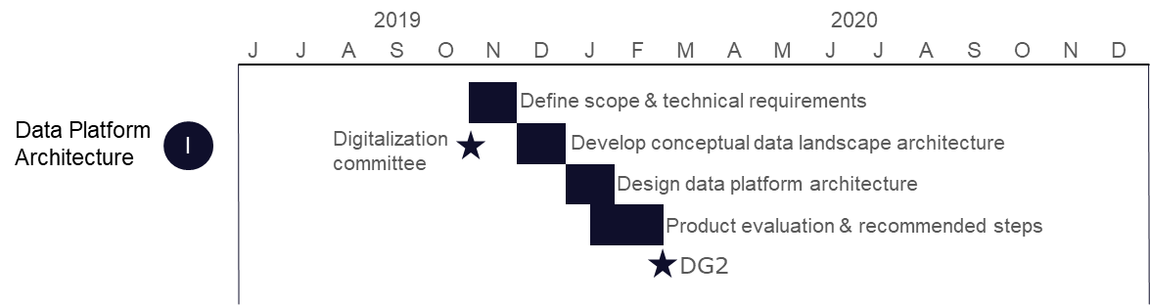

**Project Plan and Schedule for Detailing the Architecture**

# Risks and Mitigations

## Risk Analysis

|  |  |  |  |  |  |
| --- | --- | --- | --- | --- | --- |
| **ID** | **Risk** | **Severity** | **Likelihood** | **Mitigation** | **Owner** |
| 1. |  |  |  |  |  |
| 2 |  |  |  |  |  |

<<Note: The above table provides a simple risk assessment for small projects. More complex risk management methodologies/spreadsheets may be substituted where relevant.>>

## Assumptions

The following table summarizes assumptions for this Statement of Architecture Work:

|  |  |  |  |
| --- | --- | --- | --- |
| **ID** | **Assumption** | **Impact** | **Owner** |
| 1. |  |  |  |

Risiko knyttet til arkiteturen (ikke projekt)

Feks: Cloud arkitetur mot eksisterende on-prem løsninger à drift etc

# Acceptance Criteria and Procedures

## Metrics and KPIs

The Implementation phase of the Data Platform will deliver a MVP / PoC of the architecture, and is thus a validation of the architecture. As such, the deliverable of the Implementation project will implicitly show if the architecture is a success or not.

## Acceptance Procedure

This will be provided when the procedure is set by the Architecture board.

# Signature Approvals

|  |  |
| --- | --- |
|  |  |
| Signature | Date |